Answer 1.
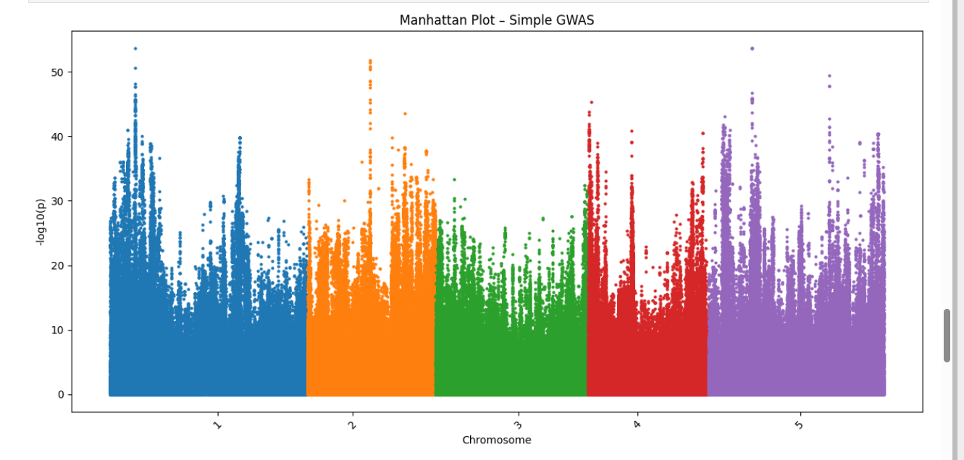

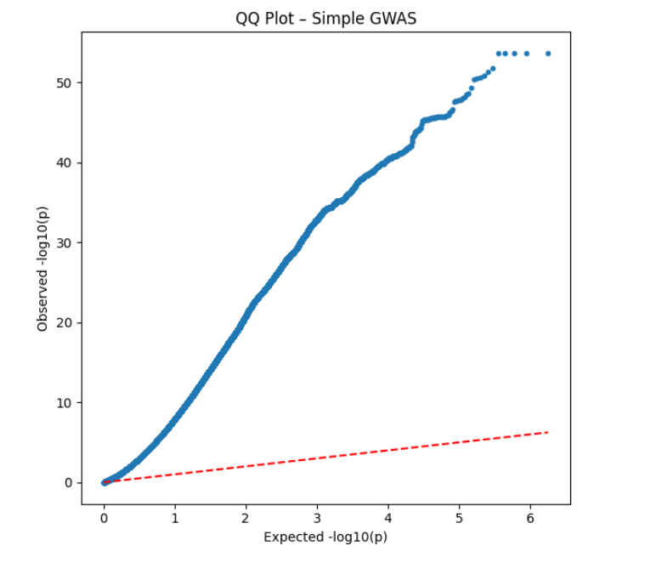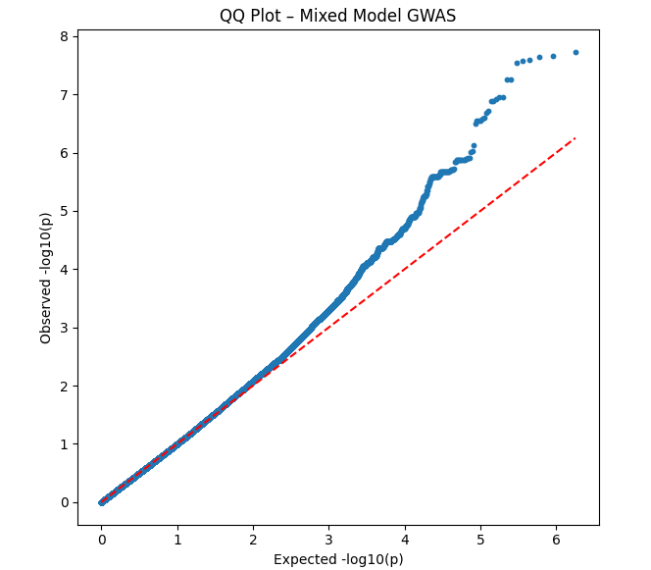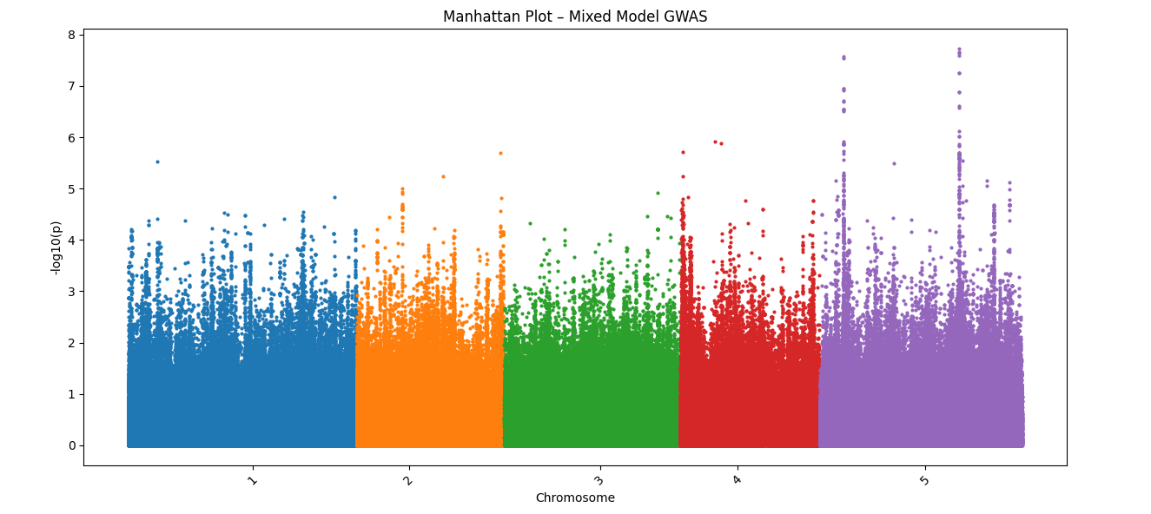

Answer 2. Number of significant SNPs is higher in simple GWAS with higher log score. They are false positive because population structure is not correct. In MLM GWAS background noise is lower. They are some significant peaks, wapwcially chromosome 5.

Answer 3.
In simple GWAS QQ plot, there is a huge deviation from redline, which means many false positive. In MLM GWAS, point following the red line, which means population structure and relatedness are correct. P-value is reliable.

